**OSYS 1200 Lab 11 Ch. 12 Client Hyper-V**

This lab requires that you do it on **a physical machine**. Use the computers in lab 312 or your own**. Make sure your version of Windows is not a home version, as Hyper-V client will not run.**

When this entire lab is completed, you will delete the Hyper-V Virtual Machine, Virtual External nic, then uninstall Hyper-V client from the physical machine.

You will lose network connectivity when you create your External Virtual Switch, so when done for the day, disable the Virtual External nic. Once Windows is installed, you should have your nic back.

If you do not uninstall the Hyper-V client, VMware will not run.

Nov. 25 Update:

If you have a Mac system or cannot run Hyper-V due to having a home version of Windows 10, install VBox and Install Windows 10. Give yourself a nice desktop. If you have VBox installed try VMWare again and install Windows 10.

The idea was to use Windows 10 Pro or higher to use Hyper-V. This year OSYS 1200 is not running in the campus lab, so this will be a substitute for the lab.

If you can use Hyper-V, do activities 12-1, 12-2, 12-3 only. Although there are other activities listed with directions, skip them.

Activity 12-1

* Step 1: Click Start, type cmd, then right click on the Command prompt icon and select Run as Administrator.
* Take a screen capture of the result of step 3

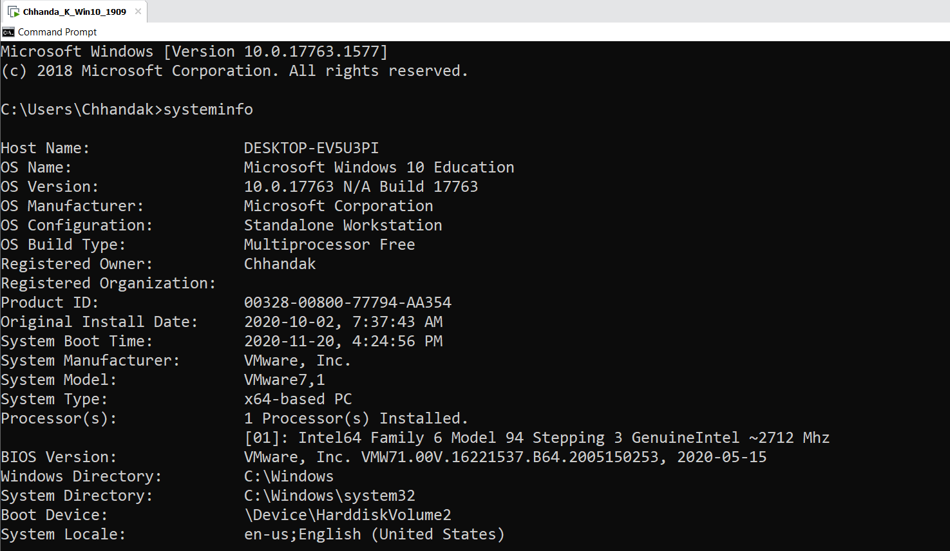

* Take a screen capture of the result of step 6

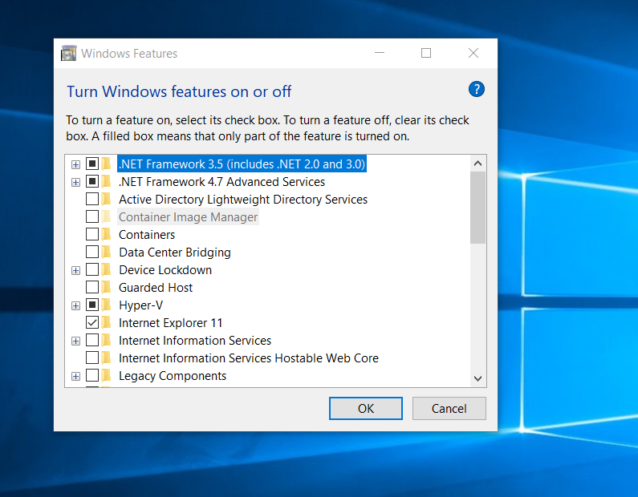

Activity 12-2 Creating an External Virtual Switch

* Take a screen capture of the result of step 4

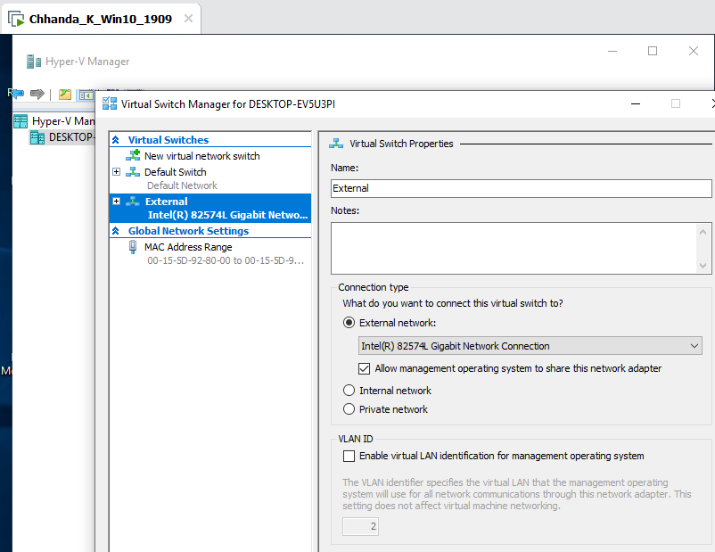

* Take a screen capture of the result of step 6

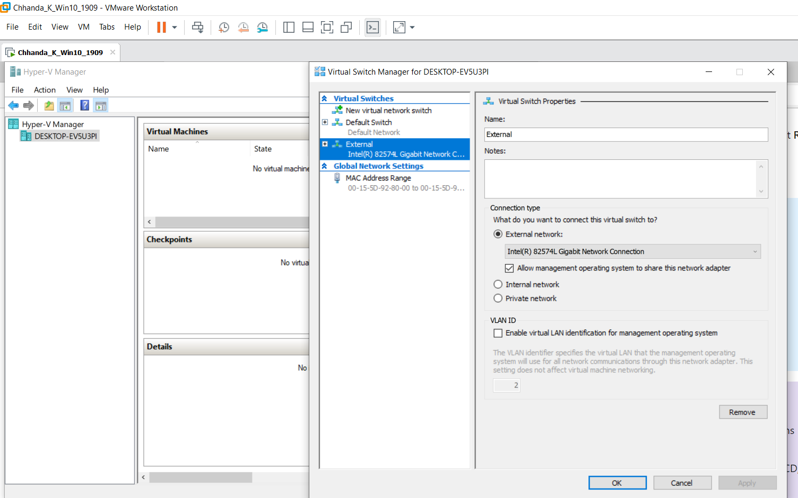

* Be aware of the warning in step 9, you will lost network connectivity on the physical box until Windows is installed.

Activity 12-3: Creating a Virtual Machine (about an hour to do)

* Follow directions exactly up to step 5 naming the file lastnamefirstinitial-Win-10-Ch-12 (So for me it would be: larusicg-Win-10-Ch-12)
  + **NOTE**: **if you are using a separate or external hard drive for storage, check the Store the Virtual Machine in a Different Location check box and browse to your external drive and put the new virtual machine and all associated files for it in that location. Then click Next**
* In step 6, keep default Generation 1. **Do not use Generation 2!**
* Take a screen capture of step 9.

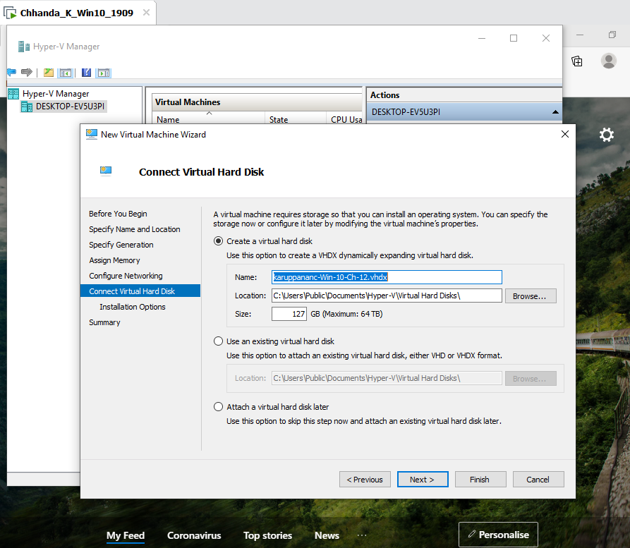

* Follow steps 10, 11 and 12.
* Accept default for step 14 and **DO NOT use 2 for Number of Virtual processor**
* Follow step 15
* In step 16, you should not have to add the DVD drive. However, if necessary, substitute IDE for SCSI controller. If it is not already there Add the IDE DVD drive.(It is because you used Generation 1 set up that SCSI DVD is not available.)
* Follow step 17 and use the iso you used when you created your VM Win 10 in Activity 1-1 Ch. 1
* Do step 18, but instead of clicking on Firmware, (it’s not there), click on BIOS and ensure Boot from IDE is first on the list
* Take a screen capture of the result of step 18
* Skip 19 if step 18 is correct.
* Follow step 20
* Follow step 21 and the rest while Windows 10 installs.
* Use the following KMS key for Windows 10 Pro W269N-WFGWX-YVC9B-4J6C9-T83GX and keep going until Windows 10 is installed, then take a screen capture
* If necessary do step 26, but you might as well keep it open for the next activity.

Skip Activity 12-4, 12-5, 12-6, 12-7, 12-8 (This list was updated on Nov. 25, 2020)

Activity 12-5 Identifying Integration Services

* Take a screen shot of the result of step 11
* The command is Enter-PSSession –VMName the name of your vm. In my case the command would be as follows:
  + Enter-PSSession –VMName larusicg-Win-10-Ch-12
* Take a screen shot of the result of step 14
  + If you get an error after providing credentials, exit PowerShell and move on to 12-6.
* Take a screen shot of the result of step 16
* Step 17 may not work as you are in a guest virtual machine. Instead of pressing f5, click in the Services Menu bar Action>Refresh then take screen capture of the result

Activity 12-6 Expanding a Virtual Hard Disk

* If you used your external hdd, the path in step 7 is incorrect. You will need to browse to the location you saved your virtual hard drive and work your way to the .vhdx file.
* Take a screen shot of the result of step 8
* Take a screen shot of the result of step 10
* NOTE: Steps 13 & 14 may be redundant.
* Take a screen shot of the result of step 16

Activity 12-7 Moving Virtual Machine Storage

You will be using your physical Machine. For those who used an external hdd, the directions will be modified slightly. This will take up additional space on your physical drive. For those with their own machines follow the directions as stated in this activity.

* If you used 14an external hdd, create the folder on the root of the drive. So, if your drives registers as E on your system, your folder should be E:\Win_10_Ch_12
* Take a screen shot of the result of step 6
* Notice the point made in Step 10. (Have a coffee, break etc.; it’s going to take about 15 minutes)
* Take a screen shot of the result of step 11 ensuring you are in the correct folder. (That is the one showing the hard drive named as your virtual machine.)

Activity 12-8 Managing Checkpoints

* After shutting down the VM, close the Windows VM box so that only the Hyper V Manager is open.
* Take a screen shot of the result of step 5
* Take a screen shot of the result of step 7
* Take a screen shot of the result of step 13
* Take a screen shot of the result of step 14
* Take a screen shot of the result of step 15

Final steps. For machines in lab 312. The paths will differ on your external hard drives.

1. Shut down the VM and close its window.
2. In the Hyper-V Manager in the Actions centre, single click on Virtual Switch Manager
   1. In the Virtual Switches section click on External then in at the bottom right of the Virtual Switch properties, click Remove, then OK. Click Yes.
   2. To remove the virtual machine, right click on your virtual machine in the Hyper-V Manager and click on delete, delete.
   3. Close Hyper-V manager
   4. On your physical box, go to C:\ and right click on the Win10-Ch12 folder and delete it.
   5. Go to C:\Users\Public\Public Documents and delete the Hyper V folder
   6. Close all open windows
   7. Click start and type features and press enter.
   8. Uncheck the box besides Hyper-V and click OK
   9. Reboot.